2.3. Some apps have location tracking system which may not be useful when donor’s GPS is off.

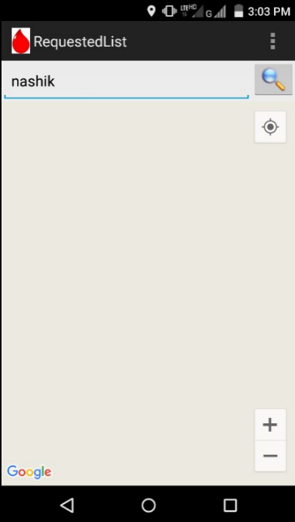

Fig.2.3.1: Screenshot of Donate Blood Save Life’s